**Effects of Combining Particle Swarm Optimization with Genetic Algorithms to Minimize Deceptive Cases**

**Daniel N. Khalil**

*Computer Science*

*Artificial Intelligence Club*

Daytona Beach, Florida

600 South Clyde Morris Blvd.

**Luke R. Crump**

*Software Engineering*

*Artificial Intelligence Club*

Daytona Beach, Florida

600 South Clyde Morris Blvd.

**Abstract**

This research explored hybridizing Particle Swarm Optimization (PSO) and Genetic Algorithms (GA). Computational efficiency and quality of solution were measured for multiple hybrid variations. It was found that the the hybrid algorithm performed slightly better than PSO and GA in **x/x** tests when executed on solution spaces with many local minimums.

**Introduction**

Heuristic optimization techniques have become a widespread technique within the field of machine learning [1]. Applications extend to training Neural Networks, approximating solutions to NP-Complete problems, pattern recognition, and Heuristic evolutionary optimization algorithms such as Genetic Algorithms (GA) and Particle Swarm Optimization (PSO). The concept of meta-heuristics proposes that "it is often sufficient to find an approximate or partial solution"[1]. By sacrificing accuracy, these algorithms gain efficiency. Although defining the scope of all possible solutions determines the accuracy of heuristic algorithms. If the solution space becomes larger or deceptively holds multiple viable solutions, the disadvantage of using meta-heuristics becomes the increasing loss of accuracy.

Population-based Meta-Heuristic algorithms have tools such as GA's mutation rate and PSO's cognitive and social components that allow exploration of a given solution space. These tools allow for convergence on optimal solutions even within solution spaces with multiple local minimums or maximums. The hybrid algorithm proposed includes both the exploration and convergence components of GA and PSO together. This research tests whether this combination will enact a positive effect on the efficiency and quality of the result. There have been various implementations of hybridization between meta-heuristic algorithms [2][3][7] This research explores yet another implementation and/or perspective into the hybridization of two meta-heuristic algorithms.

**Definitions**

**Solution** **Space**: The set of all possible solutions to a specific problem.

**Optimization**: The process of finding the best solution or solutions out of a range of possible solutions.

**Machine Learning:** a subset of Artificial Intelligence that allows an algorithm to learn and improve performance from experiences in an environment.

**Heuristic:** A problem dependent algorithm that is supposedly faster and more efficient than traditional methods by sacrificing accuracy, or completeness.

**Metaheuristic**: A high-level problem independent algorithm that uses heuristic methods to allow application to a broad variety of problems.

**Genetic Algorithm (GA)**: a metaheuristic technique that utilizes evolution of solutions based off of survival of the fittest.

**Particle Swarm Optimization (PSO):** a metaheuristic technique that utilizes the movement of solutions based off of communication of other solutions within a solution space.

**Genetic Algorithm**

Genetic Algorithm (GA) are an evolutionary metaheuristic optimization algorithm based on Darwin's theory of evolution and survival of the fittest. The algorithm initially constructs a population **p** of random solutions in the given solution space, encodes them, then will run through the following steps per generation:

1. **Evaluation**Evaluation includesfor each **pi**within **p** assign a fitness value based on the location of **pi** in the solution space.
2. **Selection**Selection includes picking solutions within the population to breed new solutions. In this research the *Tournament* method was used
   1. pick two solutions randomly from **p** (**p**i, **p**j)
   2. if eval(**p**i) > eval(**p**j): then: return **p**i  
      else: return **p**j

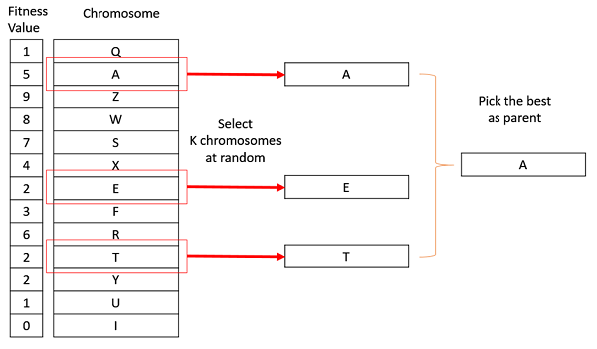

1. **Crossover**Crossover includes breeding two parent solutions together to create a child of those two solutions. In most cases GA will encode their solution within a binary string and splice both parent binary strings together. although in this research a real number version of crossover BLX was used to create children.   
     
   BLX is a method of crossover that blends real number solutions together while adding some random variation for exploration [**10**]

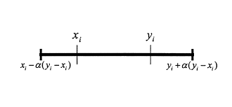

1. **Mutation**

Mutation provides diversity to each new generation, so it doesn't get trapped in deceptive cases. In this research **pi**has a chance to be multiplied by a floating-point value that is between zero and two.

Repeating these steps until an optimal solution has been found, Genetic Algorithms eventually converges the entire population to a solution inside the solution space.

The critical aspects of how GAs find a solution is in how they explore and converge. Exploration is affected by the selection and mutation methods of GA and is essential to help the population not get stuck in deceptive cases. Convergence is affected by the selection and crossover methods of GA and is essential to moving the entire population towards a specific solution.

**Particle Swarm Optimization**

Particle Swarm Optimization (PSO) is a metaheuristic optimization algorithm based off the social behavior of birds. PSO instead of using the practice of selection and crossover, uses a mathematical vector equation that uses the position of the specific particle, the position of the best particle, and randomness to explore and converge on a solution

The algorithm initially constructs a population of particles that contain a random solution between the upper and lower bounds of the solution space, assigns each particle a random velocity vector **vi** within the bounds of the solution space. Then runs through these steps.

**gBes**t - the swarm’s global best position within the solution space

**pBes**t - a particle’s personal best position within the solution space

**ω** – inertia parameter (normally between 0.6-0.9)

**φ**p – social component parameter (normally 2)

**φg**– cognitive component parameter (normally = φp = 2)

**r** – random number between 0-1

1. **Evaluation**  
   Evaluates the particle’s solution: **x**i
2. **Update-pBest**  
   If the particle’s solution is better, then it’s personal best it updates that particles personal best: **p**i
3. **Update-Swarm’s-gBest**  
   If the particle’s solution is the best solution out of the entire swarm then the global best solution is updated **g**d
4. **Update each particles velocity**  
   **v**i,d ← ω **v**i,d + φp *r*p (**p**i,d-**x**i,d) + φg *r*g (**g**d-**x**i,d)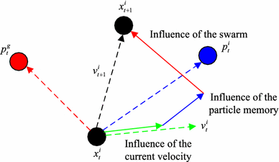
5. **Updates particle’s position**

**p**i ← **p**i+ **v**i,d

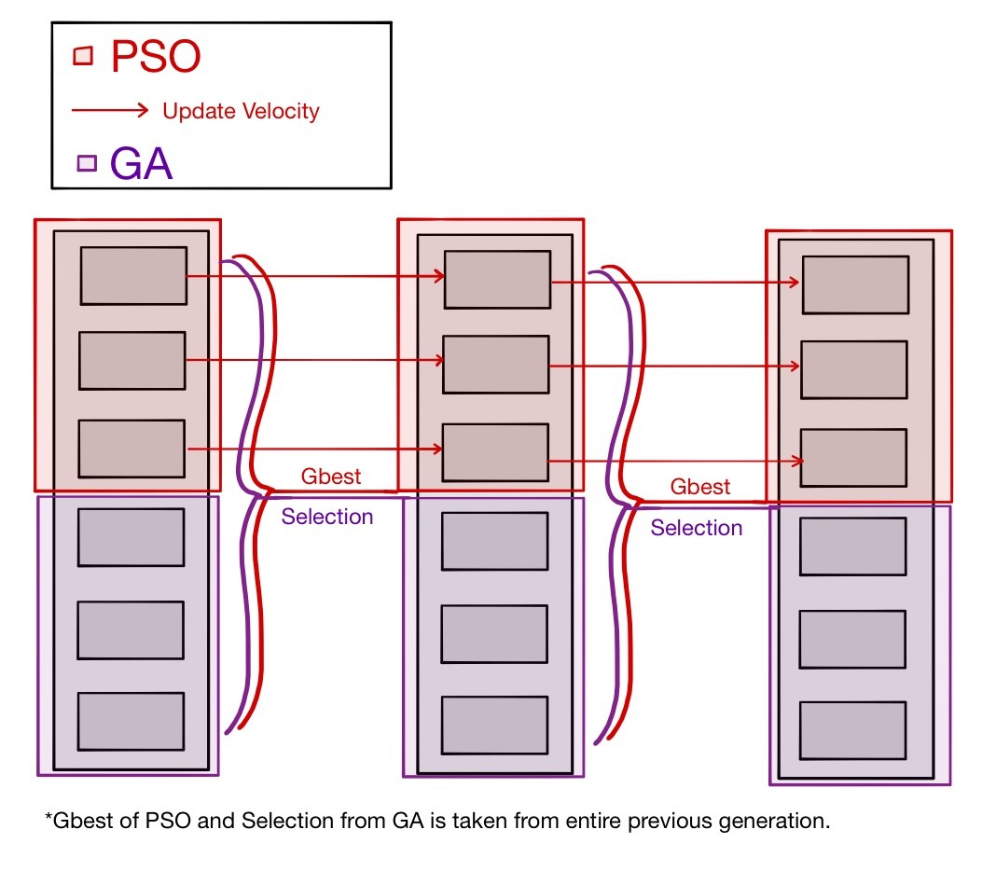These steps repeat for each particle for each epoch. To promote convergence the velocity vector equation uses the social component to move each of the particles towards the global best solution, to promote exploration of the solution space the random parameter **r** is multiplied to each component of the equation, as well as the inertia parameter ω.

**Hybrid**

To test whether the hybridization of PSO and GA is viable. GA, and PSO will be tested against 3 different hybrid algorithms. If these algorithms are awarded a higher fitness, in a shorter amount of iterations it will be accepted that these algorithms perform better than the nonhybrid versions of GA or PSO.

The Hybrid Algorithm will:

1. **Instantiate:**  
   construct a population of random solutions vectors within the bounds of a solution space.
2. **Encapsulate a percentage of Particles**  
   encapsulate a percentage of those individual solutions within a particle object that contains a personal best and global best as well as a velocity vector.

For each Generation:

1. **Update pBest**  
   Personal best updates based on the current particles position.
2. **Update gBest (from entire population)**Global best updates based off the entire population’s global best solution.
3. **Update Allocated Particle Velocities**  
   Particles update velocities of the first ½ of the population
4. **Update Allocated Particle Positions**Particles update position the first ½ of the population
5. **Select Parents (from entire population)**GA will select parents from the entire population
6. **Crossover & Mutation of Children**  
   GA performs crossover and mutation to fill up the other ½ of the population with children.

These steps will repeat to converge to a solution.

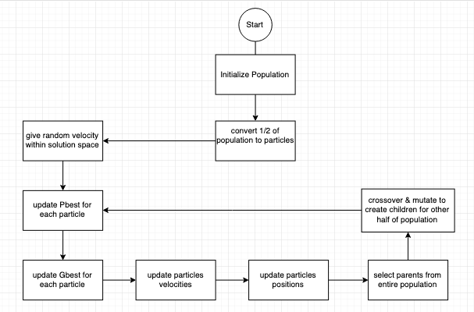

The hybridization of PSO and GA, is to increase the exploration of the population through the solution space. As the population will utilize the exploration components of Particle Swarm Optimization (Inertia, and random aspects of the velocity calculation), as well as the exploration aspects of Genetic Algorithm, (mutation rate, and selection).

Adding this extra exploration aspect will hopefully allow convergence to a more optimal solution within solution spaces that contain either extra noise, or more local minimums / local maximums.

**Benchmark Functions**

|  |  |
| --- | --- |
| **Name** | **Function** |
| Ackley's function | https://lh6.googleusercontent.com/BqTjKqIMEd396aoe5C1_L_AbNxLn7vJy5yKveZ3EsGGeq3tVPISHxY4t0LiNK2lC1JkqAGFG-qfjN42HCWWL8mZtKmgsTFX_vjYY3SbiEf4FIF4iIT7Is5AXi_ZR5JUgZS9rFART |
| Eggholder function | https://lh5.googleusercontent.com/NM91deT3uvWQUZCOpxAm9_M_Ra8np7lmzRjGmD_FuYtWyivUAGFaoo8oIdwxbI8uUJwAcBRefXI8owKAlqRnmF7g90oAKyu2yjo5qfekMEz14i9B0wBV-SLSFsA1odsF-apxDkPK |
| Holder Table function | https://lh6.googleusercontent.com/UCpwYhyOEodTYbvAxVMwyNpvLyopHwOrGYZLE7Uss6Ay2CrCIR1y3IJyb-g1JE6-Ojw43wEld7XC_qQlh-kOsMXe40Yqg7kZnzOPtWzHxsXTW8baIOV1h16HhIpt5QLomDNozfop |
| Levy function | https://lh6.googleusercontent.com/Iqcsi0XIdMhVH0718VE5VnL2_kQie1Pyu0MncpzraLUl1PWc1ve48-U0-CjvDRKUqxe8esuBjr4dVPBb6nu6BnlpgLvSDuu07t6imgJXh5atXZjjNsGqgMWqYY5KGTSQecNFZb61 |
| Rastrigin function | https://lh3.googleusercontent.com/3gz3IboUxAliZ-PnxYXLZRBQ3U5hRiMqE9596sJ6JCvkKnnLx49tUmzLfpvuINc_N5eLLYsiyzn3CxXekP4igfDJ5xzPDbNH6ZRmwR9uufOLXcwj-7CWwow7S_Dy9uss0dzRNGN9 |
| Sphere function | https://lh5.googleusercontent.com/1btHiIHr48djQPAA4uEhc1uWguqVAQboDbnQ30qF1QC0JXAANU1-8EdscIzdIDXty_Xz7jTJGqvWNjeVSGFjY6tdX8ljFKMm8qkV2rrRDB8N00QQzfHPwFTRQBSoK9_ClpNXq79p |

**Experimental Design**

Plotting the fitness over 20 iterations on each the 6 different optimization benchmark functions, all three algorithms are executed to understand efficiency. In this test the algorithms will be optimizing for the global minimum, so the favorable fitness of each algorithm will be the smallest value.

|  |  |
| --- | --- |
| Algorithm | Parameters |
| GA | Mutation rate: 0.1  Population: 25 |
| PSO | Cognitive Component: 2  Social Component: 2  Inertia: 0.9  Population |
| Hybrid Algorithm | Cognitive Component: 2  Social Component: 2  Inertia: 0.9  Mutation rate: 0.1  Population: 25  switchRate: 0.2 |

(Each Algorithm is executed 100 times then averaged to find the data points that go inside the test cases)

The test cases will go as follows:

**Benchmark Function 1, 2, 3 … 6**

|  |  |  |  |
| --- | --- | --- | --- |
| Iteration | GA | PSO | Hybrid |
| 0 |  |  |  |
| 1 |  |  |  |
| 2 |  |  |  |
| … |  |  |  |
| 19 |  |  |  |

**Results**

The pattern found was that the hybrid algorithm did not outperform in benchmark functions with less prominent local minimums.

Although in functions that had many local minimums the hybrid algorithm performed slightly better than both Genetic Algorithm and Particle Swarm Optimization. For example, the Rastrigin function is a function that the hybrid algorithm would outperform GA and PSO for every dimension.

To check how the hybrid algorithm would perform on solution spaces that contained plateaus; the GA, PSO and the hybrid algorithm were executed using the Easom function which has a large area containing a plateau.

The Easom function’s hybrid algorithm execution had a slightly quicker convergence speed then particle swarm optimization, although the difference was within 1-2 iterations. 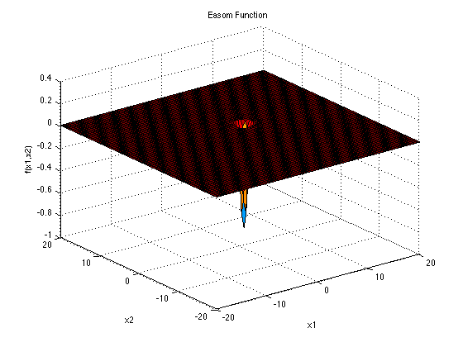

**Conclusion**

The proposed Genetic Algorithm and Particle Swarm Optimization hybridization outperformed GA and PSO only slightly in situations that contained many local minimums / local maximums. Although, the act of changing the algorithm to expand on exploration affected the convergence speed of the algorithm on solution spaces with no/few local minimums or maximums.

Particle Swarm Optimization is an excellent algorithm when paired with real number problems. In the experiment, we executed with the parameters we utilized Particle Swarm Optimization had a faster convergence speed than the Genetic Algorithm; inversely, Genetic Algorithms performed better when it came to the exploration of the solution space. Thankfully when it came to optimizing solution spaces with many local minima and maxima, the hybrid GAPSO Algorithm used both of those strengths and converged on the optimal solution in fewer iterations because of it.

Particle Swarm Optimization and Genetic Algorithms, if executed with the right parameters, always finds the global minimum of the Sphere Function, and Ackley’s function, although when these algorithms are put up against solution spaces with noise, or fluctuation, they stop becoming viable solutions to problems. The GAPSO hybrid created during this paper set out to push that boundary slightly further and succeeded. Although the improvement to the exploration to aid metaheuristic optimization algorithms to get over deceptive problems continues to hinder convergence speeds.

**References**

**[1]** Heuristic and Meta-Heuristic Algorithms and Their Relevance to the Real World: A Survey

<https://ijcert.org/ems/ijcert_papers/V2I55.pdf>

[**2**]PSO-GSA (Particle Swarm Optimization, Gravitational Search Algorithm Hybrid

<https://ieeexplore.ieee.org/abstract/document/6141614>

[**3]** Gene selection in cancer classification using PSO/SVM and GA/SVM hybrid algorithms

<https://ieeexplore.ieee.org/abstract/document/4424483>

[4]GA and a novel PSO-GA-based hybrid algorithm

<https://www.sciencedirect.com/science/article/pii/S0020019004003254>

[5]Variable-Length Particle Swarm Optimization for Feature Selection on High-Dimensional Classification

<https://ieeexplore.ieee.org/document/8458226>

[6]How efficient are genetic algorithms to solve high epistasis deceptive problems?  
<https://ieeexplore.ieee.org/abstract/document/4630806>

# [**7**]Development and validation of different hybridization strategies between GA and PSO <https://ieeexplore.ieee.org/document/4424823>

[8]Dealings with Problem Hardness in Genetic Algorithms

<https://bib.irb.hr/datoteka/407953.29-202.pdf>

[9]The Ant Colony Optimization Meta-Heuristic

<https://citeseerx.ist.psu.edu/viewdoc/download?doi=10.1.1.184.955&rep=rep1&type=pdf>

[10]A crossover operator using independent component analysis for real-coded genetic algorithms

https://ieeexplore.ieee.org/document/934452